**DIGITAL MARKETING**

**ASSIGNMENT :1**

|  |  |
| --- | --- |
| Name | ATHIRA V K |
| Reg No | 960220106039 |
| NM ID | 83B1B849E88CCF6B9384E898C62232B4 |
| Team ID | NM2023TMID10148 |

Create a blog or website using Blogspot and WordPress.  
Customize the theme design and post new article with 500  
words.

**Blogspot:**

[**https://nixonfashions.blogspot.com/2023/08/nixon-fashions.html**](https://nixonfashions.blogspot.com/2023/08/nixon-fashions.html)

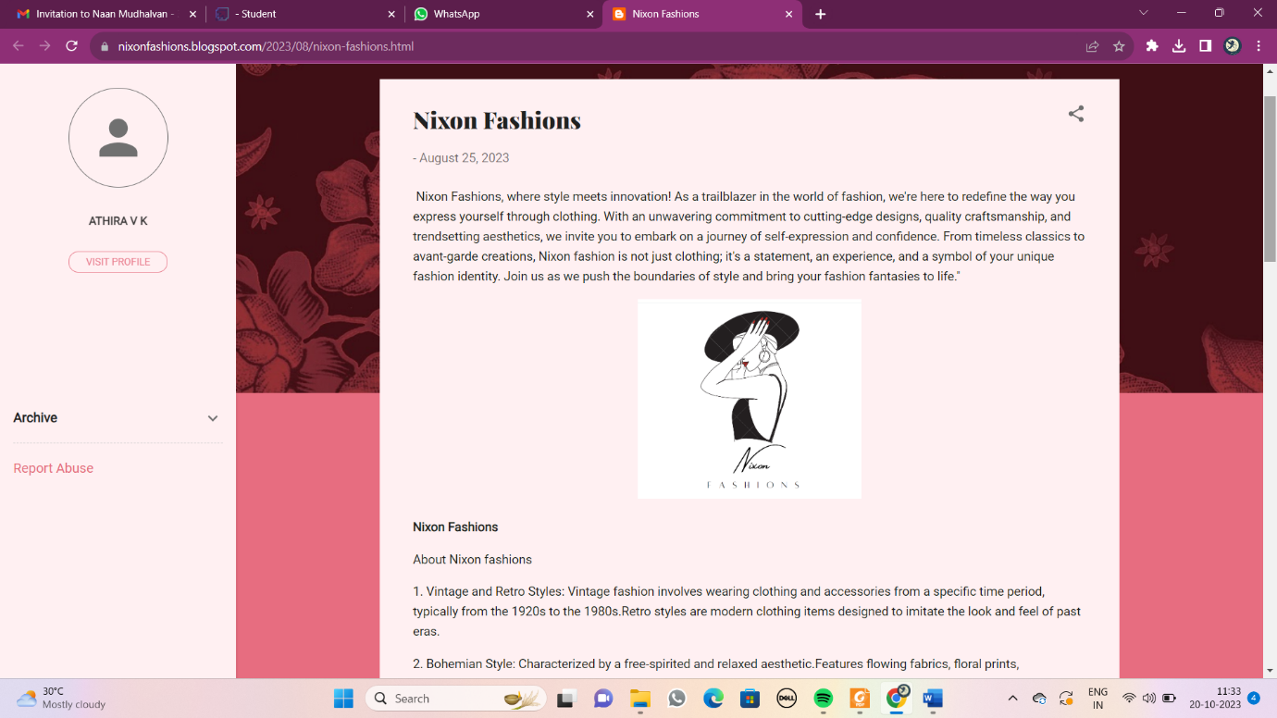

**Word press:**

[**https://athiravk.wordpress.com/2023/10/08/nixon-fashions/**](https://athiravk.wordpress.com/2023/10/08/nixon-fashions/)

